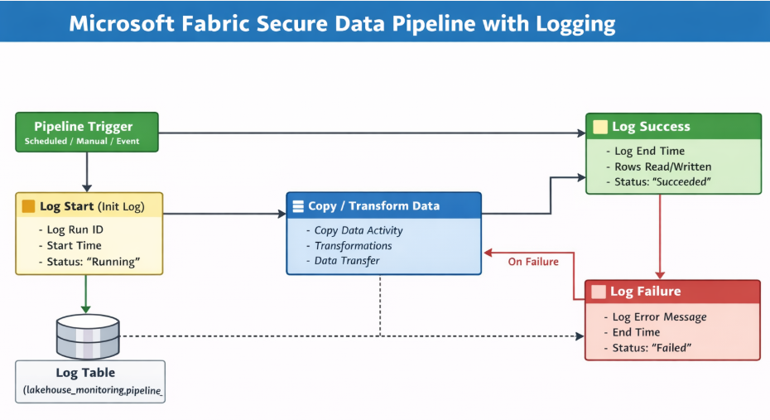

How to log pipeline runs
https://www.youtube.com/watch?v=m3BTkHrtw9A

